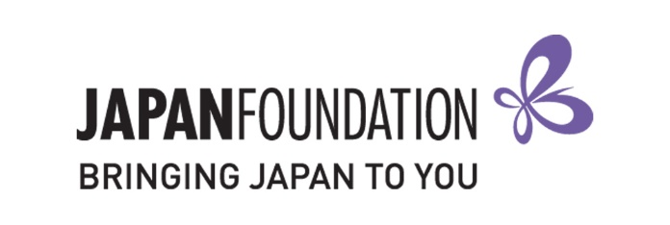
Teaching Materials Grant – 2020
FORM A (Application Form)
This is a restricted Word document. Please TYPE your responses.

Select your grant stream:

Establishing New Program Expanding Existing Program

Details of Applicant (Institution)
School Name
Postal Address
Town
State
Postcode
Principal
Phone
Sector | GOVERNMENT CATHOLIC INDEPENDENT
Level | PRIMARY JUNIOR SECONDARY SENIOR SECONDARY

Details of Authorised Official (Teacher in Charge of Application)
Name
Work email
Mobile

Japanese Program Details
Number of students at the school
Number of students taking Japanese
Number of Japanese classes
Total number of hours of Japanese taught in a week

Grant History
Has the school applied for a grant from The Japan Foundation, Sydney (JPF Sydney) in the past?
If so, provide details below (including which grants and when).

Reason for Application
Introduce your school and its community (max. 140 words).

Describe your Japanese language education program, including its current and future goals (max. 140 words).

Explain what you intend to do with the funds provided by this grant (max. 140 words).

Application Checklist
I have chosen the correct grant.
I understand and agree to the conditions outlined in the Application Guidelines.
I have a copy of all application documents for my own records.
I am sending the following items to the address below by the deadline:
- Items to be sent
- Completed original FORM A (Application Form)
- Purchasing list (only filling out the “Plan to Purchase” section)
- Send to: coordinators@jpf.org.au

Please note: Successful applicants will be asked to later submit an original copy of this form (with original signatures) along with their grant acceptance notice.

Authorised Official  (Teacher in Charge of Application) |  | School Representative  (e.g. Principal, Head of Department)
Name: |  | Name:
School Name: |  | School Name:
Position: |  | Position:
Signature: |  | Signature:
Date: |  | Date:

