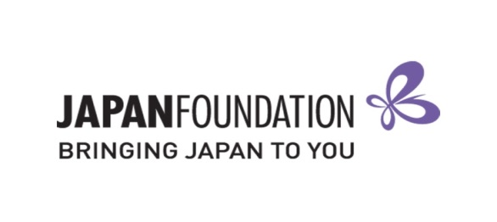
Teaching Materials Grant – 2019/20
FORM B (Reimbursement Form + Feedback)

On the basis of my Notice of Grant Approval issued by The Japan Foundation, Sydney (JPF Sydney), I hereby accept the support offered for the further development of the Japanese program at the school below, and request that JPF Sydney pay the grant amount to the nominated bank account.
This is a fillable form, TYPE your responses.
I have enclosed the completed FORM B including Feedback and “Purchasing List”.
I have enclosed ORDERING records and PAID records for each item.
I have INDICATED each item number CLEARLY in BOTH the ordering forms and paid records to match.
I understand that any receipts not received by The Japan Foundation, Sydney by the Reimbursement
Claim Deadline will not be considered for reimbursement.
I have purchased all items within the Purchase Period.
I have kept a copy of all documents for my own records.

BSB
Account Number
Account Name
Grant type: Establishing New Program Expanding Existing Program
$
$
$

Estimated amount on the notice of Grant Approved:
Purchased:
Final amount of the Grant settled:

Feedback

1. Overall, how useful did you find the Teaching Materials Grant?
Very useful Useful Neutral Somewhat Useful Not Useful

2. Do you have any suggestions to improve this Grant in the future?

3. Do you have any further comments?

Authorised Official (Teacher in Charge of Application) |  | School Representative  (e.g. Principal, Head of Department)
Name: |  | Name:
School Name: |  | School Name:
Position: |  | Position:
Signature: |  | Signature:
Date: |  | Date:

