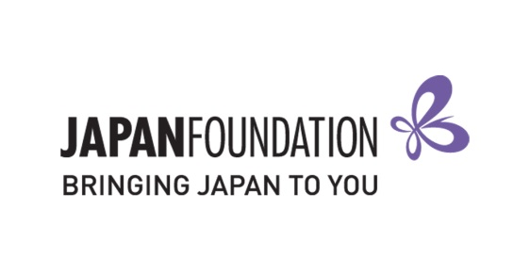
Teaching Materials Grant - 2018/19
Request to Change Approved Materials [FORM C]

This is a fillable form. Please read carefully and TYPE your responses.

If you are not able to purchase pre-approved items for some reason (e.g. out of stock, sold out etc), please fill out this form and send it to coordinators@jpf.org.au for approval before purchasing. Please note that the purchasing period is 21 May 2018 – 20 August 2018.

Procedure:
- Submit following completed documents to coordinators@jpf.org.au.
- FORM C
- List of Replacement Items for Purchase
- Once your FORM C is approved, you will be notified.
- Purchase your approved items accordingly.

Note: Your original approved grant amount remains the same regardless of any FORM C changes.

Teacher in Charge of Application
Name:
School Name:
Position:
Signature:
Date:

