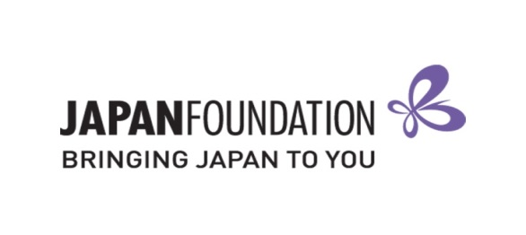
Teaching Materials Grant – 2018/19
Reimbursement Claim Form + Feedback [FORM B]

On the basis of my Notice of Grant Approval issued by The Japan Foundation, Sydney, I hereby accept the support offered for the further development of the Japanese program at the school below, and request that The Japan Foundation, Sydney pay the grant amount to the nominated bank account.
This is a fillable form. Please read carefully and TYPE your responses.
I have enclosed the “List of Materials for Purchase”, with both “Plan to purchase” & “Purchased” sections completed.
I have enclosed the completed [FORM B] including Feedback.
I have enclosed proof of ORDERING records for each item.
I have enclosed proof of PAID records for each item.
I have INDICATED each item number CLEARLY in BOTH the ordering forms and paid records to match.
I have enclosed the approved Request to Change Approval Materials [FORM C] (if applicable).
I understand that any receipts not received by The Japan Foundation, Sydney by the Reimbursement Claim Deadline will not be considered for reimbursement.
I have kept a copy of all documents for my own records.
I have purchased all items within the Purchase Period, 21 May – 20 August 2018.

BSB
Account Number
Account Name
Grant type Establishing New Program Expanding Existing Program
$
$
$

Approved amount:
Granted amount:
Amount actually spent:

$
Reimbursement amount:
Feedback

1. Overall, how useful did you find the Teaching Materials Grant?
Very useful Useful Neutral Somewhat Useful Not Useful

2. Do you have any suggestions to improve this Grant in the future?

3. Do you have any further comments?

Teacher in Charge of Application |  | School Representative  (e.g. Principal, Head of Department)
Name: |  | Name:
School Name: |  | School Name:
Position: |  | Position:
Signature: |  | Signature:
Date: |  | Date:

