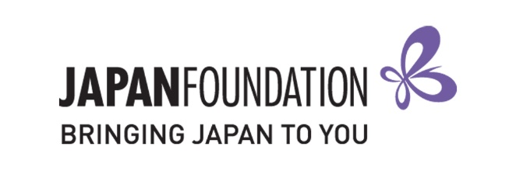
Teaching Materials Grant 2020-2021
【Special support for COVID-19】
Form A (Application Form 2)

This is a fillable form. Please TYPE your responses.
Details of Applicant
School name
Postal address
Suburb
State / Territory
Postcode
Principal’s name
Phone
Sector | GOVERNMENT / CATHOLIC / INDEPENDENT
 | PRIMARY / JUNIOR SECONDARY / SENIOR SECONDARY

Details of Teacher in Charge of Application
Name
Position
Work email
Mobile

Japanese Program Details
Number of students at the school
Number of students taking Japanese
Number of Japanese classes
Total number of hours of Japanese taught in a week

Grant History
Has the school applied for a grant from The Japan Foundation, Sydney (JPF Sydney) in the past?
If so, provide details below (including which grants and when).

Reason for Application
Introduce your school and its community (max. 140 words).

Describe your Japanese language education program, including its current and future goals (max. 140 words).

Explain why your school is eligible to apply for this grant, and what you would intend to do with the grant funds (max. 140 words).

Application Checklist
I understand and agree to the conditions outlined in the Application Guidelines.
I am submitting following items to coordinators@jpf.org.au.
- Completed FORM A (Application Form).
- Purchasing list (only filling out the “Plan to Purchase” column) as Excel.
I keep original document of completed FORM A for submitting by post if successful.

Teacher in Charge of Application |  | School Representative  (e.g. Principal, Head of Department)
Name |  | Name
School Name |  | School Name
Position |  | Position
Signature |  | Signature
Date |  | Date

