Matsuri: Bon-odori
Task 1: Colour the picture following the Japanese keys. (PPT slide no.11)
おとこのこ ゆかた：black おび：brown げた：blue
おんなのこ ゆかた：yellow おび：green げた：red

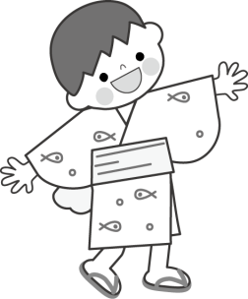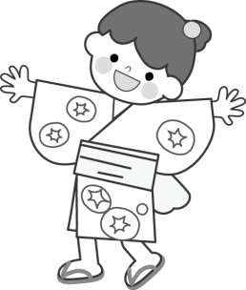

Task 2: Complete the words below in Japanese by using the hiragana characters on the right. Use each hiragana once only. (PPT slide no.11)

ゆ

か

た

お

び

げ

た

う

ち

わ

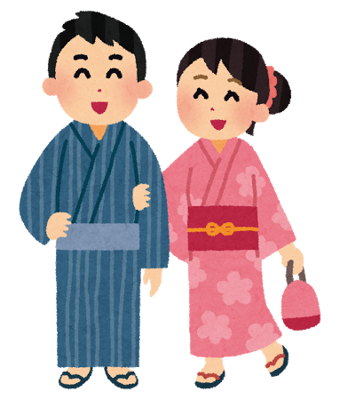
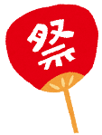

Task 3: Look at the pictures below and write down the differences and similarities in yukata for men and women. (PPT slide no.12)
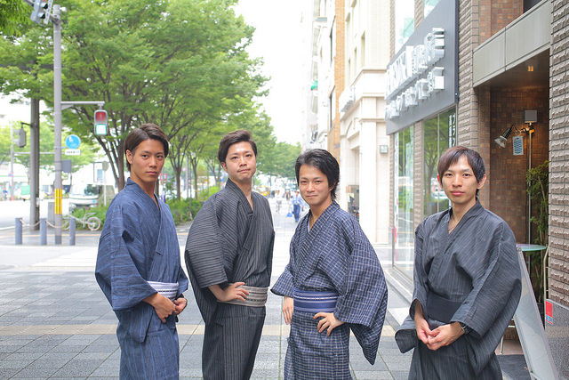 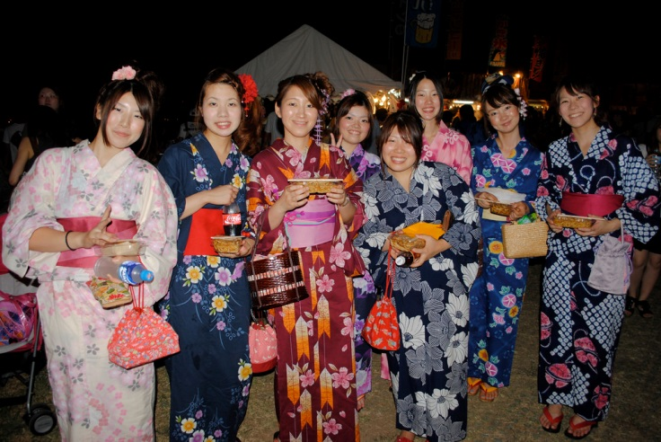 Photo by Hiro - Kokoro☆Photo Photo by calltheambulance
おなじ
ちがう

Task 4: Colour each Yukata with colours of your choice and write the colours in Japanese below. (PPT slide no.13-14)
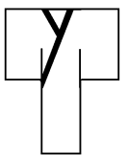

Task 5: Make yukata with origami and stick it on this sheet. Describe what colour your yukata and obi are in Japanese. (PPT slide no.15)
れい：ゆかたはあかです。おびはあおです。
わたしのゆかた

