★Task
Task 1

Research some patterns or designs from various countries/regions.
What are they? What do they signify? Share them in groups.
Task 2

Writing Task: Underline the words in the passage below which you will change
to write your own.
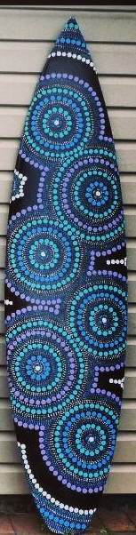

デザインは、まるです。
あおと、みどりです。
いみは、うみです。
うみは、おおきいです。
きれいです。
オーストラリアじんは、
うみがすきです。
うみは、オーストラリアの
シンボルです。

Vocab list: デザイン design まる circle/s てん dot/s いみ meaning
みず water うみ sea オーストラリアじん Australian
オーストラリア Australia シンボル symbol
Task 3

Design your own pattern for a new surfboard in the box. The design must reflect an aspect of Australian culture. Describe the design in Japanese.
ぼくの/わたしのもんよう

___________________________________________________________________

___________________________________________________________________

___________________________________________________________________

___________________________________________________________________

___________________________________________________________________

___________________________________________________________________

