What is もんよう?
1. What are these? Circle the correct words to describe the patterns below.
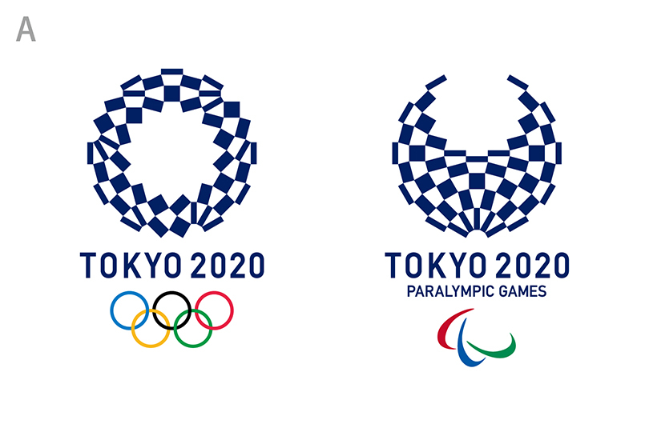

These are the Japanese Olympic emblems which include Japanese (contemporary / traditional) pattern.
The pattern was first recognised in (Kimono / Yukata) which was worn by a Kabuki actor whose name was Ichimasu Sanogawa.
This pattern is known as (いちまつもんよう/ さのがわもんよう).
Kabuki is a classic Japanese dance theatre, and usually performed by (female actress / male actor).

2. What is this pattern below called in your culture? What is this pattern often used for? Write the answers in the box.
