WHAT IS RAKUGO?

1. Rakugo is a { } year old tradition of comic monologue storytelling in Japan.

あ）100 い）400 う）800 え）1,000

2. A minimalistic performing art, rakugo features a lone storyteller dressed in a kimono, kneeling on a cushion, using only a fan and a hand towel as props. 絵とことばをマッチしてください！

kimono cushion hand towel fan

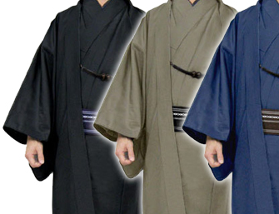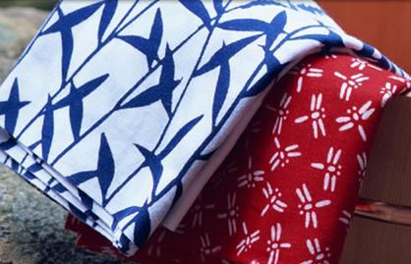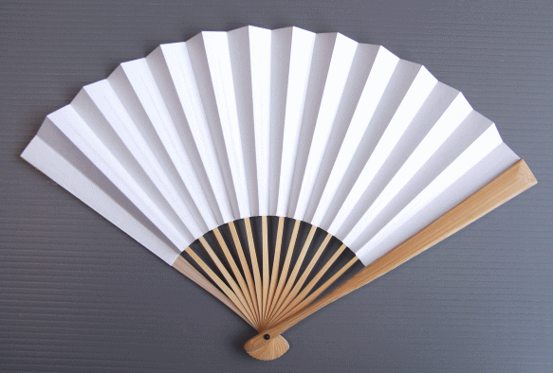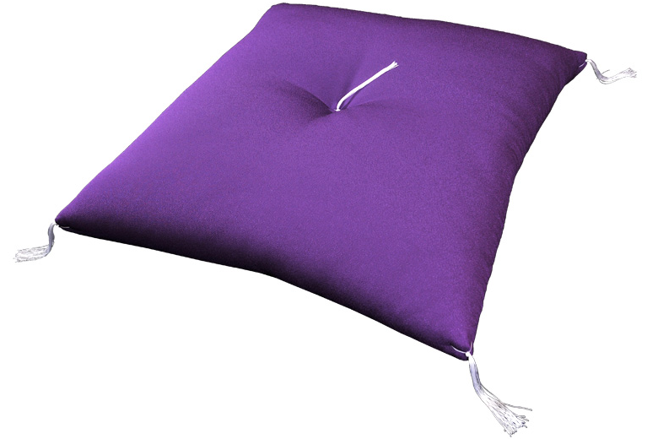

てぬぐい きもの せんす ざぶとん

3. The rakugoka (storyteller) differentiates characters in conversation by moving his head from left to right, as well as with subtle changes in tempo, posture and intonation. Rakugo is an ancient art form, but is still very much alive and well, with over { } professional storytellers practicing today.

あ）300 い）700 う）1,000 え）1,200

4. Today there are two main traditions of rakugo. Rakugo from Tokyo is called Edo Rakugo, while rakugo from Osaka is called { }.

あ）Naniwa Rakugo い）Yarou Rakugo
う）Kyou Rakugo え）Kamigata Rakugo

5. In order to become a professional rakugoka, one must be apprenticed to a master, from whom one receives a{ } .The apprenticeship is very strict. The apprentice cleans the master’s house, prepares and folds kimono, and learns the art of storytelling by watching the master perform.

あ）stage name い）comic tale う）kimono え）fan

For more information, check out these websites!
Katsura Sunshine Official Website www.katsurasunshine.com
Katsura Sunshine Explains Rakugo www.youtube.com/watch?v=IkvKIedDUu0

快楽亭ブラック Kairakutei Black
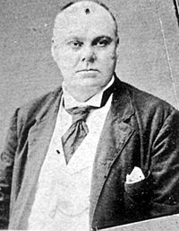
Japan’s first born foreign rakugoka is Australian! His name is Henry Black. Having been raised speaking Japanese, in 1878, after working as an English teacher, Henry Black met Shorin Hakuen II (二代目松林伯圓), who inspired him to become a rakugoka. He eventually joined the San’yu guild, where he adapted European texts as rakugo stories). Black took the name Kairakutei in 1891.

