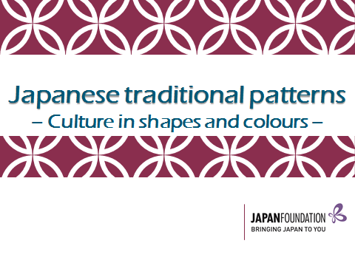
Focus questions:
What are Japanese traditional patterns?
How are traditional patterns culturally significant in Japanese society? Why?
What do traditional patterns symbolise?
What patterns are significant in your culture?

Your name: なまえ
Japanese
English

What is もんよう?
1. What are these? Circle the correct words to describe the patterns below.
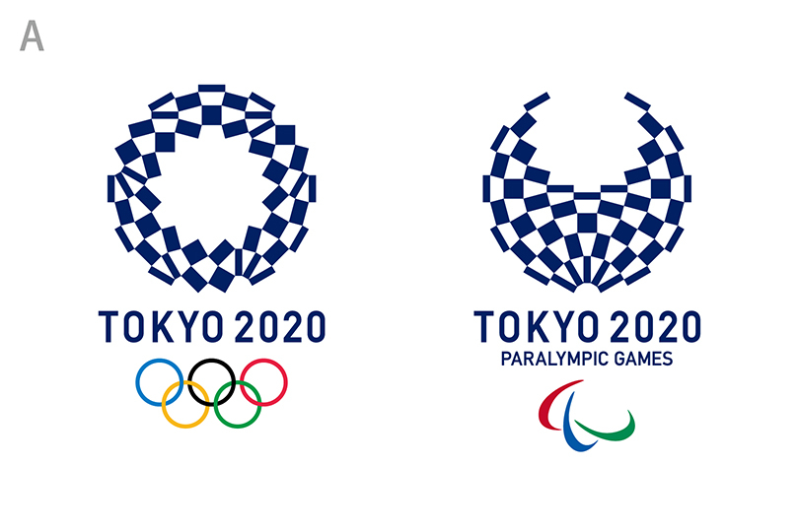

These are the Japanese Olympic emblems which include Japanese (contemporary / traditional) pattern.
The pattern was first recognised in (Kimono / Yukata) which was worn by a Kabuki actor whose name was Ichimasu Sanogawa.
This pattern is known as (いちまつもんよう/ さのがわもんよう).
Kabuki is a classic Japanese dance theatre, and usually performed by (female actress / male actor).

2. What is this pattern below called in your culture? What is this pattern often used for? Write the answers in the box.
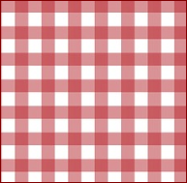

Colours in traditional patterns
1. Match the colours to the hiragana

あか きいろ

しろ

あお

ピンク むらさき

みどり
くろ
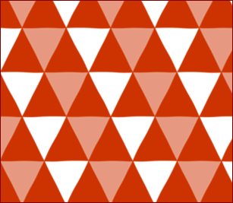
2. Write the colours of the patterns in the boxes below using the letters given.
あ

か

お
あ

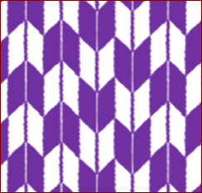
さ
ら
き
む

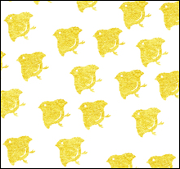

き
い
ろ

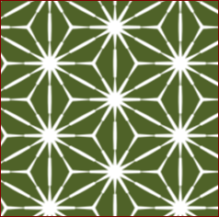
み￥
り
ど

3. What is your favourite colour? Write the colour in Japanese .

4. Ask each other what your favourite colours are.
Q: なにいろがすき？ A:＿＿＿＿がすき。
3. What are the names of these shapes? Write the number in the shapes.
Word bank: 1.まる 2.おうぎ 3.さんかく 4.しかく
5.ごかく 6.ろっかく

3. かたちはなんですか？Find various patterns in traditional patterns

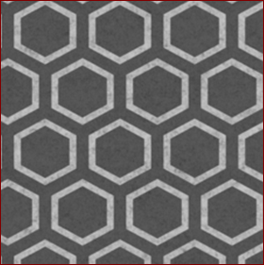

4. いくつありますか？ Count the number of shapes in the patterns.

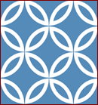
2
4
3
1

おうぎ しかく まる さんかく
（ ） （ ） （ ） （ ）
5. Fill in the empty spaces
Shapes | Kanji | Hiragana | English
 | ---- | まる
 | ---- | おうぎ
 |  |  | triangle
 | 四かく
 |  | ごかく
 | 六かく
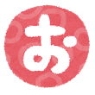
5a Draw Japanese patterns of your choice in the kimono and colour them in.
Trace the Hiragana of the colours.
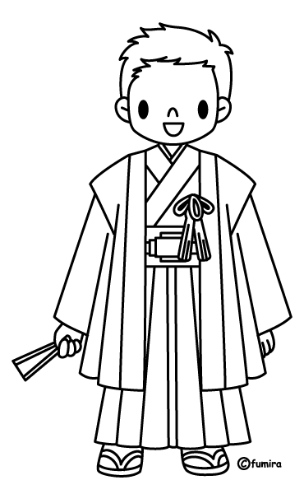
ちゃいろ
あお
あか
きいろ
くろ
しろ
みどり
きみどり‘り
むらさき
ピンク
オレンジ
グレー

Q: What shapes did you include in the patterns of Kimono? Write them in Japanese.

5b Draw Japanese patterns of your choice in the kimono and colour them in.
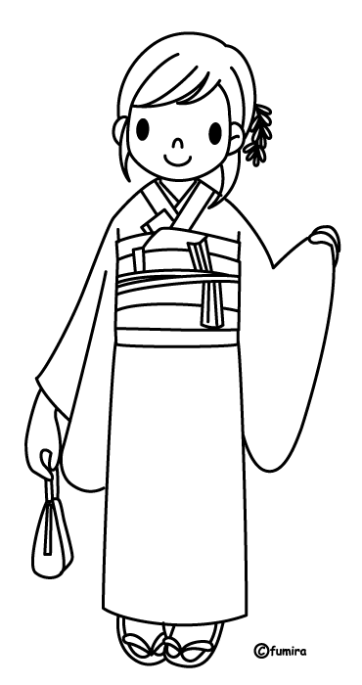
Trace the Hiragana of the colours.
ちゃいろ
あお
あか
きいろ
くろ
しろ
みどり
きみどり‘り
むらさき
ピンク
オレンジ
グレー

Q: What shapes did you include in the patterns of Kimono? Write them in Japanese.

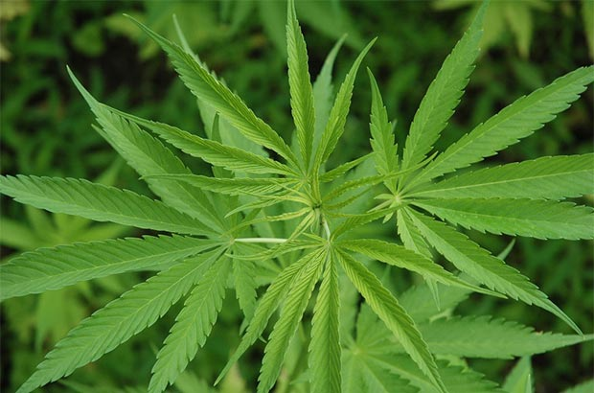
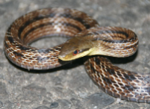
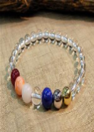
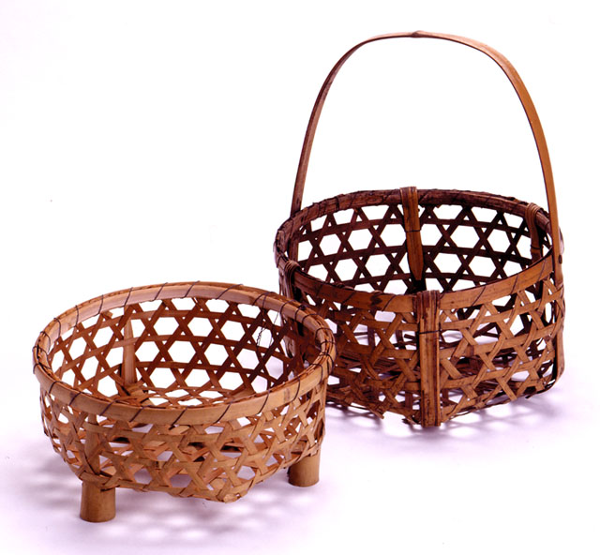
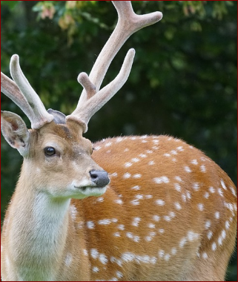
かご
たから
なみ
はっぱ
へび
しか
4
3
2
1
6
5
Meaning of the patterns
1． Match up the patterns to the pictures below.

2. What are these words in Japanese? Match the pictures to the descriptions.

- ・

かめです。
いみは、ながいきです。
*(longevity)
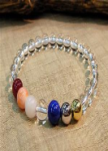

- ・

へびです。
いみは、まよけです。
*(talisman)
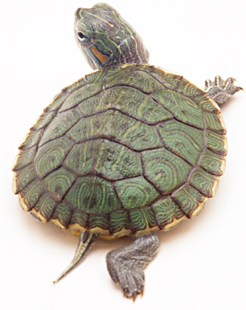

- ・

たからです。*(treasures)
いみは、ハーモニーです。*(harmony)

- ・

なみです。
いみは、へいわです。(peace)

はっぱです。
いみは、せいちょうです。
*(growth)

- ・

- ・

かごです。*(baskets)
６かくです。めです。
こわいです。
いみは、まよけです。*(talisman)

- ・

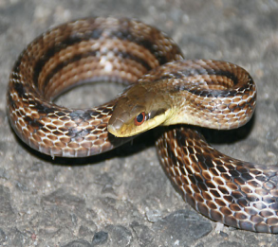

★Task
Task 1

Research some patterns or designs from various countries/regions.
What are they? What do they signify? Share them in groups.
Task 2

Writing Task: Underline the words in the passage below which you will change
to write your own.
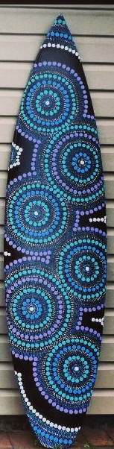

デザインは、まるです。
あおと、みどりです。
いみは、うみです。
うみは、おおきいです。
きれいです。
オーストラリアじんは、
うみがすきです。
うみは、オーストラリアの
シンボルです。

Vocab list: デザイン design まる circle/s てん dot/s いみ meaning
みず water うみ sea オーストラリアじん Australian
オーストラリア Australia シンボル symbol
Task 3

Design your own pattern for a new surfboard in the box. The design must reflect an aspect of Australian culture. Describe the design in Japanese.
ぼくの/わたしのもんよう

___________________________________________________________________

___________________________________________________________________

___________________________________________________________________

___________________________________________________________________

___________________________________________________________________

___________________________________________________________________
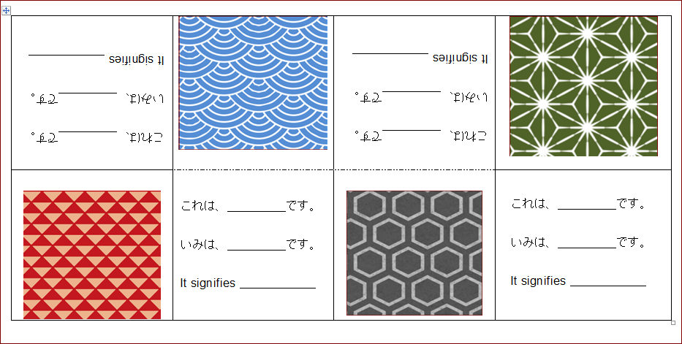
Creating a bilingual book of Japanese patterns

