かんじ

- Kanji has an on-yomi(reading) and a kun-yomi.
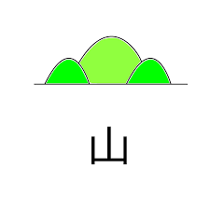
On reading:  さん | Kun reading:  やま

- How do you read 山in the following sentences. Write Furigana (Hiragana on Kanji) .

  - ふじ山

  - 山がすきです。

  - 山にのぼります。

- Practice 山 in the boxes below
山
②

③

