ふじさん○×クイズ
ほんとう？ うそ？

Use highlighter to indicate if the statements are
ほんとう(○)true or うそ(×)false.

1. Mt Fuji is higher than Mt Kosciusko.
○ ・ ×
○ ・ ×

2. Mt Fuji is not an active volcano. It doesn’t erupt.

3. There is only one route for climbing Mt Fuji.
○ ・ ×

4. You can only climb Mt Fuji in July and August.
○ ・ ×

5. In the past, women were not allowed to climb Mt Fuji.
○ ・ ×

6. You can purchase souvenirs at the top of Mt Fuji. One
○ ・ ×

souvenir available is canned air from the mountain.

7. When the sun comes out from behind Mt Fuji, you see
○ ・ ×

a beautiful scene. This is called Diamond Fuji.

8. If you dream of an eagle, an eggplant and Mt Fuji, on
○ ・ ×
ほんとう ・ うそ
Christmas eve you will have good luck in the coming year.

9. Many people climb Mt Fuji every year. The mountain is
○ ・ ×
ほんとう ・ うそ
clear of rubbish.

10. Mt Fuji became a world heritage site in 2013.
○ ・ ×

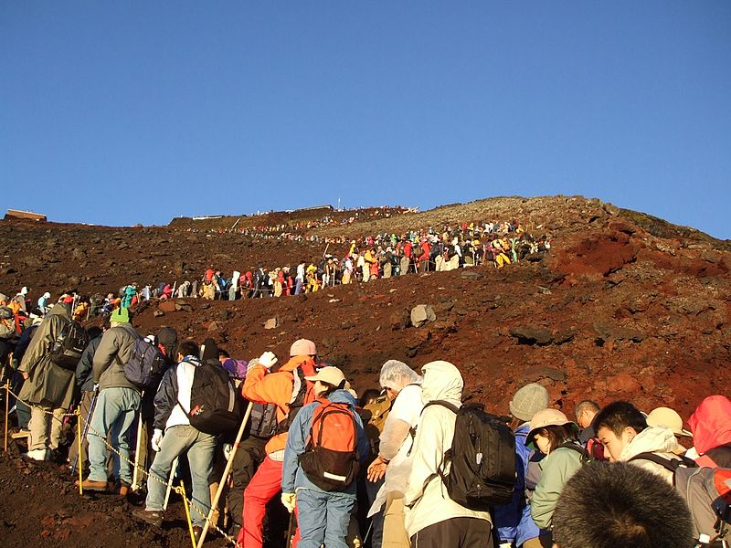
by uesaka kohei http://flickr.com/photos/54738851@N00/1028676263

