Worksheet 2 – Beat out the prefecture names in 日本 (Japan) なまえ：
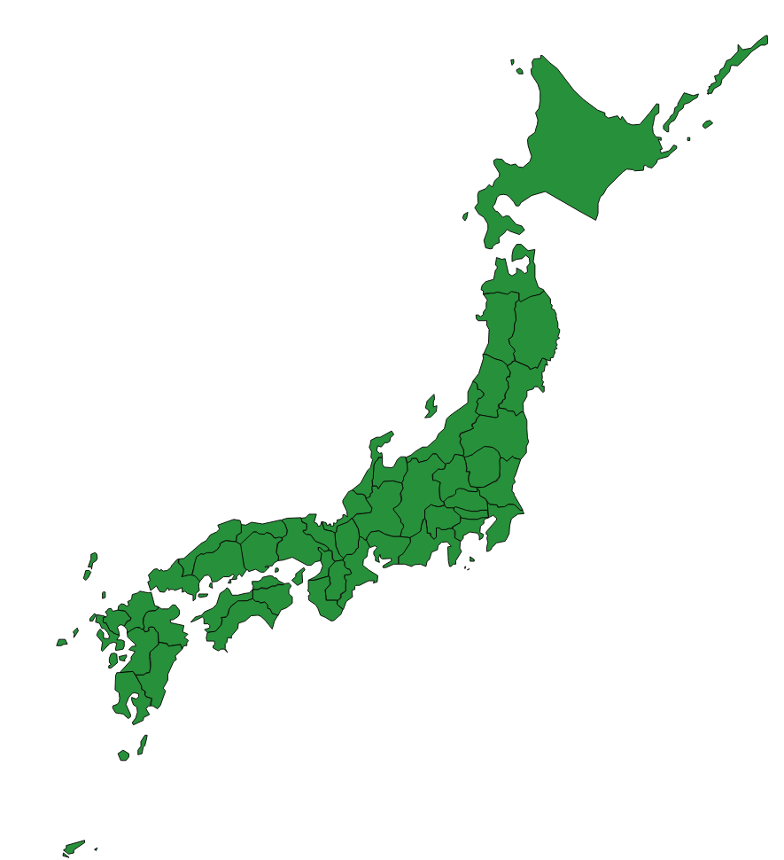
Write the names of the following prefectures in the rectangles in Japanese.
Count the mora (unit of sounds) of the prefectures and write this number in the stars.
Toukyou
Hokkaidou
Kouchi
くまもと
4
⑧
⑨
⑩
④
③
⑦
②
⑤
①
⑥
Map source: https://commons.wikimedia.org/wiki/File:Map_of_Japan_010.svg
Sendai
Tottori
Kumamoto
Ooita
Hyougo
Kyouto
Oosaka

