Chapter 1
Word Search!
Five words (a) – (e) are hidden in the word search. You will find them across (left to right) and down (top to down) ways, but not diagonally.
- うまれます to be born
- げんきな energetic, healthy
- べんきょう study
- しょうがっこう primary school
- なります to become

あ | か | し | げ | ん | き | な
い | き | す | せ | つ | に | り
う | く | べ | そ | て | ぬ | ま
え | け | ん | う | ま | れ | す
お | こ | き | た | と | ね | は
ん | さ | ょ | ち | な | ★ | ひ
し | ょ | う | が | っ | こ | う

Chapter 2
Word Search!
Five words (a) – (e) are hidden in the word search. You will find them across (left to right) and down (top to down) ways, but not diagonally.
- だいがく university
- ともだち friend
- えいご English
- むずかしい difficult
- そつぎょうします to graduate

そ | つ | ぎ | ょ | う | し | ま | す
と | ま | ゆ | ★ | あ | か | ★ | す
も | み | よ | む | い | き | だ | せ
だ | む | わ | ず | う | く | い | そ
ち | め | を | か | え | け | が | た
★ | も | ん | し | お | こ | く | ち
ん | や | え | い | ご | さ | し | つ

Chapter 3
Five words (a) – (e) are hidden in the word search. You will find them across (left to right) and down (top to down) ways, but not diagonally.
- はし bridge
- くに country
- まち town
- こうじょう factory
- できます can/be able to

★ | で | き | ま | す
ま | ち | な | の | ひ
に | ぬ | ★ | く | に
は | し | ね | は | ふ
こ | う | じ | ょ | う

Match words with pictures!
Match the flags below with the names of the countries.
Choices:
- イギリス
- イタリア
- スイス
- スウェーデン
- ドイツ
- フランス
- ベルギー
① ____________

② ____________
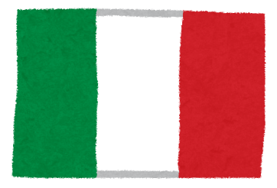
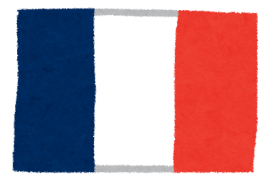
⑦ ____________
⑥ ____________
⑤ ____________
④ ____________
③ ____________
Chapter 4
Word Search!
Three words (a) – (c) are hidden in the word search. You will find them across (left to right) and down (top to down) ways, but not diagonally.
- せいじか politician
- かえます to change
- けっこんします to get married

け | っ | こ | ん | し | ま | す
★ | せ | い | じ | か | ★ | さ
ま | や | ら | あ | ★ | か | し
み | ゆ | り | い | か | き | す
む | よ | る | う | え | く | せ
め | わ | れ | え | ま | け | そ
も | を | ろ | お | す | こ | た

Chapter 5
Word Search!
Five words (a) – (e) are hidden in the word search. You will find them across (left to right) and down (top to down) ways, but not diagonally.
- いえ house
- つくります to make
- とち land
- こめ rice
- がいこく foreign country

あ | え | ★ | き | つ
★ | が | い | こ | く
い | お | え | め | り
★ | と | ち | く | ま
う | か | ★ | け | す

Chapter 6
Word Search!
Five words (a) – (e) are hidden in the word search. You will find them across (left to right) and down (top to down) ways, but not diagonally.
- はじめます to start
- うります to sell
- たかい expensive
- せいふ government
- かります to borrow

た | う | ら | れ | は
か | り | ま | す | じ
い | ま | り | ろ | め
★ | す | る | ん | ま
せ | い | ふ | ★ | す

Match words with pictures!
Match the following words with the right picture.
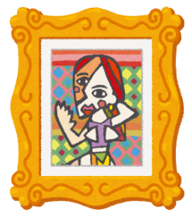
①
にんぎょう

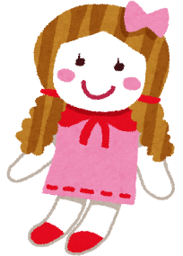
②
え

③
かぞく

みせ
④
Chapter 7
Word Search!
Four words (a) – (d) are hidden in the word search. You will find them across (left to right) and down (top to down) ways, but not diagonally.
- め seedling, bud, sprout
- ちかい close/near
- はる spring
- おきます to happen

め | は | ち | に
★ | る | か | ほ
ん | ★ | い | ん
お | き | ま | す

Match words with pictures!
Match the following words with the right picture.
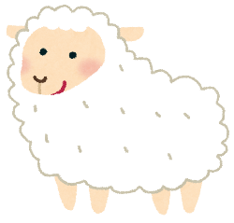
①
かわ

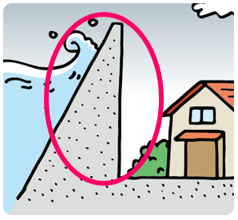
②
ひつじ

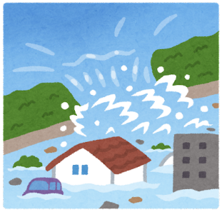
③
あめ

④
こうずい

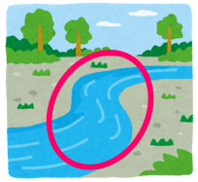
⑤
ていぼう
Chapter 8
Word Search!
Four words (a) – (d) are hidden in the word search. You will find them across (left to right) and down (top to down) ways, but not diagonally.
- はたらきます to work
- つよい strong
- かなしい sad
- あき autumn

さ | し | せ | つ | た | あ
★ | す | そ | よ | ち | き
か | な | し | い | つ | ★
は | た | ら | き | ま | す

Chapter 9
Word Search!
Three words (a) – (c) are hidden in the word search. You will find them across (left to right) and down (top to down) ways, but not diagonally.
- あきらめます to give up
- おわります to end
- みず water

★ | や | ゆ | よ | ん | お
ま | み | む | め | も | わ
か | ず | き | く | け | り
こ | ★ | さ | し | す | ま
あ | き | ら | め | ま | す
さ | し | す | せ | そ | ★

Answer keys
あ | か | し | げ | ん | き | な
い | き | す | せ | つ | に | り
う | く | べ | そ | て | ぬ | ま
え | け | ん | う | ま | れ | す
お | こ | き | た | と | ね | は
ん | さ | ょ | ち | な | ★ | ひ
し | ょ | う | が | っ | こ | う
Chapter 1

Chapter 2
そ | つ | ぎ | ょ | う | し | ま | す
と | ま | ゆ | ★ | あ | か | ★ | す
も | み | よ | む | い | き | だ | せ
だ | む | わ | ず | う | く | い | そ
ち | め | を | か | え | け | が | た
★ | も | ん | し | お | こ | く | ち
ん | や | え | い | ご | さ | し | つ

Chapter 3
★ | で | き | ま | す
ま | ち | な | の | ひ
に | ぬ | ★ | く | に
は | し | ね | は | ふ
こ | う | じ | ょ | う

① (a) イギリス ② (c) スイス ③ (e) ドイツ ④ (g) ベルギー
⑤ (d) スウェーデン ⑥ (f) フランス ⑦ (b) イタリア

Chapter 4
け | っ | こ | ん | し | ま | す
★ | せ | い | じ | か | ★ | さ
ま | や | ら | あ | ★ | か | し
み | ゆ | り | い | か | き | す
む | よ | る | う | え | く | せ
め | わ | れ | え | ま | け | そ
も | を | ろ | お | す | こ | た

Chapter 5
あ | え | ★ | き | つ
★ | が | い | こ | く
い | お | え | め | り
★ | と | ち | く | ま
う | か | ★ | け | す

Chapter 6
た | う | ら | れ | は
か | り | ま | す | じ
い | ま | り | ろ | め
★ | す | る | ん | ま
せ | い | ふ | ★ | す

①え (picture, painting) ②にんぎょう (doll) ③みせ (shop) ④かぞく (family)

Chapter 7
め | は | ち | に
★ | る | か | ほ
ん | ★ | い | ん
お | き | ま | す

①ひつじ (sheep) ②ていぼう (levee, bank) ③こうずい (flood) ④あめ (rain) ⑤かわ (river)

Chapter 8
さ | し | せ | つ | た | あ
★ | す | そ | よ | ち | き
か | な | し | い | つ | ★
は | た | ら | き | ま | す

Chapter 9
★ | や | ゆ | よ | ん | お
ま | み | む | め | も | わ
か | ず | き | く | け | り
こ | ★ | さ | し | す | ま
あ | き | ら | め | ま | す
さ | し | す | せ | そ | ★

