ウルル
Uluru
Before Reading
- Discuss the questions below.
- How many world heritage sites are there in Australia?
- Which ones are natural heritage sites, which are cultural heritage sites, and which are mixed heritage sites?
- Which ones have you visited?
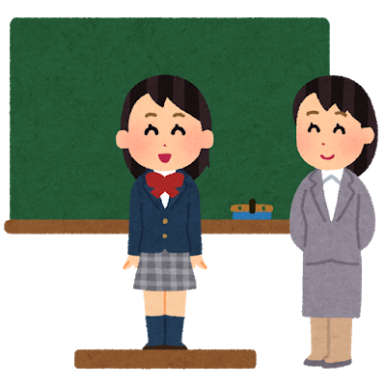
オーストラリアには、たくさん世界遺産があります。たとえば (for example) 、＿＿＿と＿＿＿です。 たくさんの人が旅行に行きます。

＿＿＿に行きましたか？

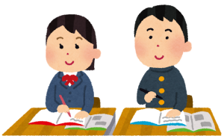
どうでしたか？

- Research
Watch the video and discuss what is happening there with your classmates.
日テレNEWS24. (2019, October 26). 「豪「エアーズロック」26日から登山禁止に」 Retrieved December 6, 2019, from https://www.youtube.com/watch?v=HJG8031FayU. (JAPANESE VIDEO about the closure of Uluru)
7 NEWS Australia. (2019, October 25). Uluru now closed to climber. Retrieved December 6, 2019, from https://www.youtube.com/watch?v=GG2pz5DHO2U. (ENGLISH VIDEO about the closure of Uluru)

During Reading
- Match the Japanese word ( ) to the English meaning below (a)-(h).
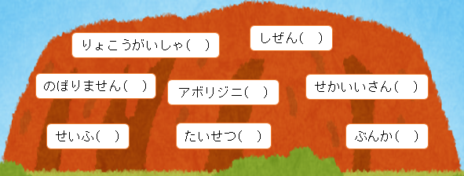
(a) important (b) culture (c) a world heritage (d) government
(e) nature (f) not to climb (g) Indigenous Australians (h) travel agency

- In the mind map, write three words that connect to the key word.
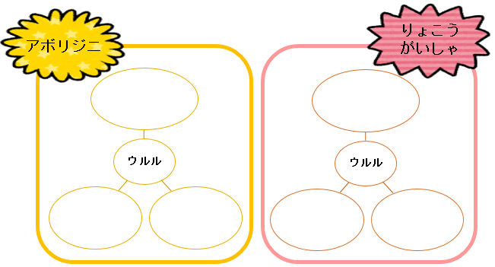

- Summarize what you have read by filling in the blanks below to complete the sentence.
オーストラリア＿＿＿＿＿＿は、＿＿＿＿＿＿年＿＿＿＿月＿＿＿＿日から、「ウルル」に___________________________________と言いました。

After Reading
- Discuss
How did the ban to climb Uluru make indigenous people feel? Research it and share your ideas with your classmates.

- Research
The text says 「いろいろなツアーがあります」. Some travel agents are currently offering an interesting tour using セグウェイ. Research this and share your findings with your classmates.
セグウェイにのります。そして、ウルルの自然をみます。きれいですよ！

- Role Play
You are working at a travel agency in Australia. You have been asked to organise a new tour to Uluru for Japanese tourists. Design a tour in groups and make a flyer.

- Research world heritage sites in Japan
- How many world heritage sites are there in Japan?
- Which ones are natural heritage sites, which are cultural sites, and which are mixed heritage sites?
- Are there any issues related to preserving world heritage sites in Japan?
- Which ones do you want to visit?
Teacher’s Note: FUJISAN (https://jpf.org.au/classroom-resources/resources/fujisan/) on Classroom Resources may be useful.

