-Teacher’s notes-
yukata

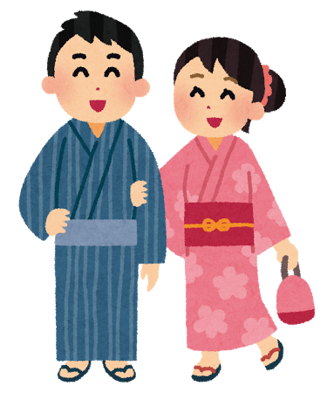
★Sample answer of Task 3:Similarities and differences of yukata for men and women(Worksheet_yukata)
(PPT slide no.12)

Similarities
- The left side of the yukata is always put over the right side.
- Both have several colours and patterns.

Differences
- Women’s yukata are more colourful and have a wider range of patterns. Yukata is usually worn in summer, so summer symbols such as morning glories (あさがお) and uchiwa (うちわ) are used as patterns. The patterns of men’s yukata are more simple.
- Most of the men’s yukata are blue, navy blue, brown, black, white or cream coloured. No bright colours are used.
- Women’s obi (sash) are much wider and more colourful than the men’s ones.
- Women’s obi (sash) are usually worn around the waist on top of the yukata and tied into a knot at the back. The obi (sash) rests just under the breast line. Men wear obi-belts on their hip bones which are lower than how women wear.
- Women who have long hair usually wear their hair up and wear hair accessories.

★Good video of how to wear yukata

おんな

ゆかた： https://www.youtube.com/watch?v=km5yOCrQwCI
おび： https://www.youtube.com/watch?v=xaTFPTOZccY
ゆかたとおび： https://www.youtube.com/watch?v=hdGAwZ6w8gw
おとこ
ゆかたとおび： https://www.youtube.com/watch?v=onQ5nDgXVLQ

