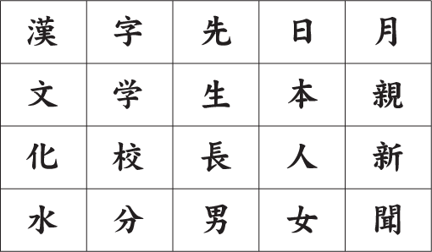
How many 2-kanji compound words can you find in the chart below? Kanji compounds may be created by combining with kanji on the left, right, above, below or diagonally

How many 2-kanji compound words can you find in the chart below? Kanji compounds may be created by combining with kanji on the left, right, above, below or diagonally

