Before reading
- Match the numbers to the explanations below.
1. ロイヤルファミリー 2. 元号 3. 新しい元号

  - On the 1st of April 2019, a new era name was announced. And on the 1st of May, a new emperor ascended the throne and the new era began in Japan.
  - Japan has a royal family with an Emperor. As the “symbol” of Japan, the Emperor’s duties involve attending events and receiving foreign dignitaries.
  - 元号 is the term for Japan’s imperial era names. In Japan, the imperial calendar is commonly used alongside the Western Gregorian calendar. Since 1868, it has been custom for the era name to change whenever a new emperor takes the throne.

- What is this person doing? How do you read this Kanji? Find the answers from the websites below.
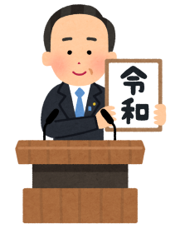
- ‘Japan reveals ？？ to be name of new imperial era ahead of Emperor Akihito's abdication’
https://www.abc.net.au/news/2019-04-01/japan-new-era-name-reiwa-emperor-akihito-abdication/10958916

- ‘Japan's Emperor Naruhito proclaims his enthronement to the world’
https://www.abc.net.au/news/2019-10-22/japan-emperor-proclaims-his-enthronement-to-the-world/11627242

- Activity 「 生まれですか？」
Using a chart, look up the birth years of yourself and your family and find out the corresponding year on the Japanese imperial calendar. ※「Worksheet 何年 生まれですか？」

- This is an actual stamp sold in Japan. What do you think it is used for?
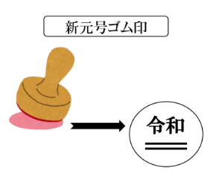

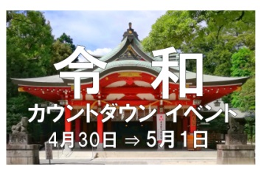
- When and where did this event take place? What sort of event do you think it is?

- There is also a company called REIWA in Australia. What sort of company is it?
Look it up online.

- This is the title of a newspaper article. What kind of news do you think this is?
「たくさんの会社が名前に「令和」とつけた」

- Vocabulary
Vocabulary
- 元号（げんごう) Name of an era
- 変わります（かわります） Change
- ～県（けん） Prefecture
- 情報（じょうほう） Information
- 役所（やくしょ） City office
- 登録します（とうろく） Register
- ゆうめい Famous

Reading
- Arrange the sentences in the correct order
（ ）令和というの会社が30ありました
（ ）新しい号に変わりました
（ ）新しい号が出ました

- Fill in the blanks according to the article
①4月1日にしい元号が出ました。そのとき、「令和」という会社は＿＿＿____ありませんでしたが、4月10日に、＿＿＿ありました。

②多いのは、 __＿＿＿＿＿が5、東京は＿＿_、と広島県と佐賀県が＿＿＿、北海道が_＿＿でした。

③までの名前を変えた会社のは、＿＿＿＿＿ありました。

- Complete the table with the number of companies dates and types
令和という名前のの数
Dates and types of companies using 令和.
4月 1日 | ①
4月 10日 | ②
新しくできた | ③
名前をえた会社 | ④

- Guess the meanings of 「調査」 and 「調べました」 in the article
調査会社の「商工リサーチ」は、どのぐらいの会社が、名前に「令和」が入っているかを調べました。
Hint1 「リサーチ」is a word borrowed from English.
Hint2 「商工」is a name of a company.

After reading
- Answer the following questions
①いつ元号が変わりましたか。
②だれが、どのぐらいの会社が名前に令和が入っているかを調べましたか。
③3月31日に「令和」という名前の会社はいくつありましたか。
④どうして、たくさんの会社が名前を変ましたか。

- Indicate whether the following sentences are true (〇) or false (×)
（ ）新しいは、5月1日にでました。
（ ）令和がに入っている会社は東京が一番多いです。
（ ）新しいが出る前は、「令和」という名前の会社は18ありました。
（ ）たくさんのが4月1日にを変えました。

- Find the meaning of the following:
・「令和」
・「令」and「和」as separate Kanji

Reference
Japan assures the world that Reiwa is all about 'beautiful harmony' and has nothing to do with 'command'
https://www.japantimes.co.jp/news/2019/04/03/national/japan-assures-world-reiwa-beautiful-harmony-nothing-command/#.Xci2IFczbIU

- Extension Task
- Japanese companies regarding 「令和」said 「の名前を新しい元号にして、いいイメージにしたいかもしれません。それから、もっとゆうめいな会社にしたいかもしれません。」. How do other Japanese people feel? Read the internet ポスト(posts) from a number of Japanese about their thoughts on the change to Reiwa.

新しい元号、令和についてどう思いますか？

新しい気持ち！お正月がもういちど来たみたい！
パソコンや書類（Documents）のシステムを変えるのがたいへん！
子どものときから、２回 元号が変わりました。
今の元号が がわるのは、少しさびしいですね。

まだ慣れない（can’t get used to）けど・・・、
これから日本が よくなってほしいな。

- What do you think of these reactions to the change to「令和」? How will it affect Japanese life in the future?
- Talk about your connection to your country, and your hope for the future(しょうらい)

