Before reading
- Match the numbers to the explanations below.
1. ロイヤルファミリー 2. 元号 3. 新しい元号

  - On the 1st of April 2019, a new era name was announced. And on the 1st of May, a new emperor ascended the throne and the new era began in Japan.
  - Japan has a royal family with an Emperor. As the “symbol” of Japan, the Emperor’s duties involve attending events and receiving foreign dignitaries.
  - 元号 is the term for Japan’s imperial era names. In Japan, the imperial calendar is commonly used alongside the Western Gregorian calendar. Since 1868, it has been custom for the era name to change whenever a new emperor takes the throne.

- What is this person doing? How do you read this Kanji? Find the answers from the websites below.
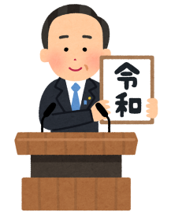
- ‘Japan reveals ？？ to be name of new imperial era ahead of Emperor Akihito's abdication’
https://www.abc.net.au/news/2019-04-01/japan-new-era-name-reiwa-emperor-akihito-abdication/10958916

- ‘Japan's Emperor Naruhito proclaims his enthronement to the world’
https://www.abc.net.au/news/2019-10-22/japan-emperor-proclaims-his-enthronement-to-the-world/11627242

- Activity 「何年 生まれですか？」
Using a chart, look up the birth years of yourself and your family and find out the corresponding year on the Japanese imperial calendar. ※「Worksheet 何年 生まれですか？」

- This is an actual stamp sold in Japan. What do you think it is used for?
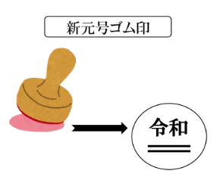

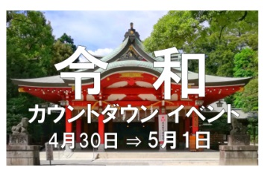
- When and where did this event take place? What sort of event do you think it is?

- There is also a company called REIWA in Australia. What sort of company is it?
Look it up online.

- This is the title of a newspaper article. What kind of news do you think this is?
「たくさんの会社が名前に「令和」とつけた」

- Vocabulary
Vocabulary
- 元号（げんごう) Name of an era
- 変わります（かわります） Change
- ～県（けん） Prefecture
- 情報（じょうほう） Information
- 役所（やくしょ） City office
- 登録します（とうろく） Register
- ゆうめい Famous

