**Activity sheet**

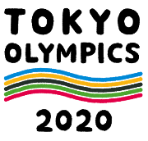**Before Reading**

1. **Research and discuss the questions below.** 
   1. **When are the Tokyo Olympics? When are the Tokyo Paralympics?**

|  |  |
| --- | --- |
| オリンピック | 月　　日～　　月　　日 |
| パラリンピック | 月　　日～　　月　　日 |

* 1. **How many sports and events are in the Tokyo Olympics and Paralympics?**

|  |  |  |
| --- | --- | --- |
|  | きょうぎ  Olympic sports | しゅもく  Events |
| オリンピック |  |  |
| パラリンピック |  |  |

* 1. **How many athletes do you think come to the Tokyo Olympics and Paralympics?**

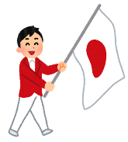

＿＿＿＿＿　ぐらいです。

* 1. **What are important features of Olympism? Tick ☑ three from the choices below.**



* + スポーツ (sport)
  + 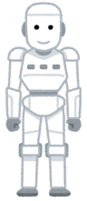ぶんか (culture)
  + びじゅつ (art)
  + かんきょう (environment)
  + テクノロジー (technology)

1. **The Tokyo Olympics and Paralympics are trying to promote the importance of the environment to Japanese citizens. Here are some possible projects for reducing CO2. Tick ☑ the ones you think are being used?**

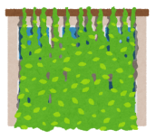

* 1. 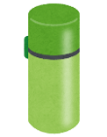_____ 　みどりのカーテン (plant curtain) をつくります。
  2. _____　エコライフ (eco-life) にチャレンジします。

　　　　たとえば、マイボトル(my own water bottle)をつかいます。

* 1. _____　ふるい(oil) をリサイクルします。

1. **Do you know of any other environmental projects planned for the Tokyo Olympics and Paralympics?**
2. **Look at the title of the article and guess what the article is about. What do you think** 「にやさしいベッド」 **is?**

オリンピック・パラリンピック：にやさしいベッド

**イメージしよう！「にやさしい〇〇」**

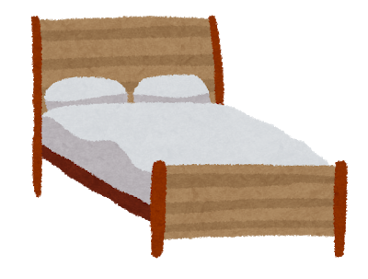　　　　 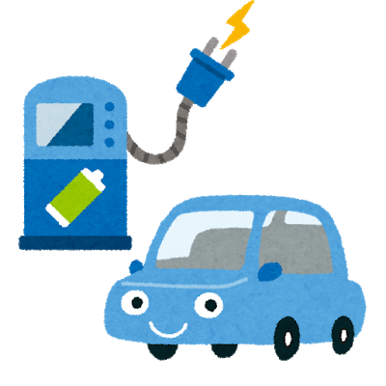　　 　　 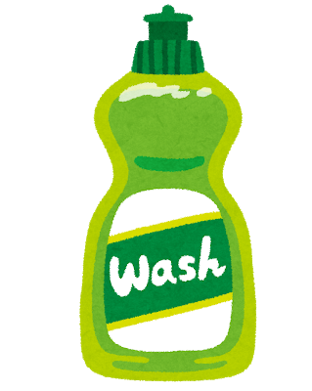

1. **Watch the video and write down what you think is happening. Discuss it with your classmates.**

________________________________________________________________________________________________________________________________________________________________________________________________________________________

ANNnewsCH. (2020, January 9). 「選手村は障害者に配慮　廊下広々、再利用OKのベッド」. Retrieved July 21, 2021, from https://www.youtube.com/watch?v=4a4blYGCuMM. (JAPANESE VIDEO about the Olympics village)

WZDW News FOX. (2019, October 25). *Athletes at 2020 Tokyo Olympics will be sleeping on cardboard beds*. Retrieved February 26, 2020, from https://www.youtube.com/watch?v=rYPO6pKxzpw. (ENGLISH VIDEO about the Olympics village)

1. **Look at the key vocabulary.**

**Find the listed words in the puzzle. Words can appear vertically and horizontally.**

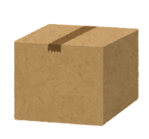

* かんきょうenvironment
* リサイクル recycle
* ダンボール cardboard
* ひつよう necessary
* やさしい friendly, kind
* つかいます to use
* すてます to throw … away

|  |  |  |  |  |  |
| --- | --- | --- | --- | --- | --- |
| **ま** | **や** | **あ** | **く** | **つ** | **し** |
| **い** | **さ** | **ろ** | **て** | **か** | **せ** |
| **け** | **し** | **よ** | **ひ** | **い** | **す** |
| **み** | **い** | **め** | **つ** | **ま** | **て** |
| **お** | **せ** | **ゆ** | **よ** | **す** | **ま** |
| **か** | **ん** | **きょ** | **う** | **む** | **す** |
| **ダ** | **ン** | **ボ** | **―** | **ル** | **わ** |
| **ま** | **リ** | **サ** | **イ** | **ク** | **ル** |

Notes: ダンボール、ボール comes from (card) board.

**During Reading**

1. **Answer the following questions.** 
   1. What did The Tokyo Organising Committee of the Olympic and Paralympic Games introduce?
   2. What are the beds made of?
   3. What will the Tokyo Organising Committee of the Olympic and Paralympic Games do with the beds after the Olympics and Paralympics?
   4. What does the writer of this article think about these beds?
2. **Summarize what you have read. Fill in the blanks below and complete the sentences with the following words.**

2020年オリンピック・パラリンピックでは、＿＿＿＿＿をたいせつにしています。ですから、＿＿＿＿＿＿＿のベッドをつくりました。オリンピック・パラリンピックのあとに、ベッドを＿＿＿＿＿＿＿します。

かんきょう

ダンボール

リサイクル

**After Reading**

1. **Indicate whether the following sentences are true (〇) or false (×).**

（　　）The beds and tables are made from cardboard.

（　　）A person who weighs 200kg can sleep on the cardboard beds.

（　　）The writer of this article said the recycled beds are a good idea.

1. **Reading extension and discussion**

**Read the following comments about the recyclable beds and mattresses, then research opinions of people around the world.**

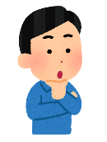

オリンピックはいろいろなから日本にきます。わたしたちのゲストです。ゲストのたちがダンボールのベッドにねます。それは、しつれい(impolite) です。



ベッドは、(newspaper)になります。リサイクルできます。いいですね！

**Share your findings and your opinions with your classmates.**

**Example:**

わたしは、ダンボールのベッドがいいです。、オーストラリアでも、かみのストローがあります。かんきょうにいいです。

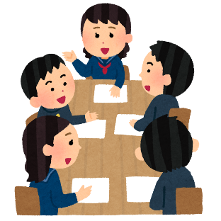

そうですね。

なるほど。

1. **Research**

**As well as the beds, there are other recyclable products that will be used for the Olympics. Research the other products and give a presentation to your class.**

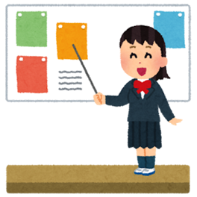**Example:**

これは、日本ののユニフォームです。ふるいで、つくりました。にやさしいです。

**Other suggestions for research:**

メダル (medal)、ひょうしょうだい(winners’ podium)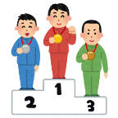

**Answer key:**

**Before reading**

**1.**

**a.** The Olympics: July 24th – August 9th / The Paralympics: August 25th – September 6th

**b.** The Olympics: 33 sports 399 events / The Paralympics: 22 sports 539 events

**c.** The Olympics: At maximum 12, 000 athletes/The Paralympics 4,400 athletes

**d.** Sport, Culture, Environment

**2.**

**a.** ☑ **b.** ☑ **c.** ☑

**6.**

|  |  |  |  |  |  |
| --- | --- | --- | --- | --- | --- |
|  | **や** |  |  | **つ** |  |
|  | **さ** |  |  | **か** |  |
|  | **し** |  | **ひ** | **い** | **す** |
|  | **い** |  | **つ** | **ま** | **て** |
|  |  |  | **よ** | **す** | **ま** |
| **か** | **ん** | **きょ** | **う** |  | **す** |
| **ダ** | **ン** | **ボ** | **―** | **ル** |  |
|  | **リ** | **サ** | **イ** | **ク** | **ル** |