Activity sheet
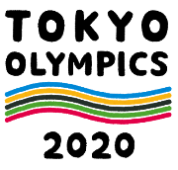
Before Reading
- Research and discuss the questions below.
  - When are the Tokyo Olympics? When are the Tokyo Paralympics?
オリンピック | 月 日～ 月 日
パラリンピック | 月 日～ 月 日

  - How many sports and events are in the Tokyo Olympics and Paralympics?
 | きょうぎ  Olympic sports | しゅもく  Events
オリンピック
パラリンピック

  - How many athletes do you think come to the Tokyo Olympics and Paralympics?
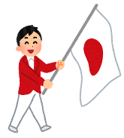
＿＿＿＿＿ 人ぐらいです。

  - What are important features of Olympism? Tick ☑ three from the choices below.
  - スポーツ (sport)
  - ぶんか (culture)
  - びじゅつ (art)
  - かんきょう (environment)
  - テクノロジー (technology)

- The Tokyo Olympics and Paralympics are trying to promote the importance of the environment to Japanese citizens. Here are some possible projects for reducing CO₂. Tick ☑ the ones you think are being used?
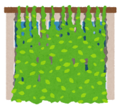
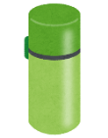
  - _____ みどりのカーテン (plant curtain) をつくります。
  - _____ エコライフ (eco-life) にチャレンジします。
たとえば、マイボトル(my own water bottle)をつかいます。
  - _____ ふるい油(oil) をリサイクルします。

- Do you know of any other environmental projects planned for the Tokyo Olympics and Paralympics?

- Look at the title of the article and guess what the article is about. What do you think 「環境にやさしいベッド」 is?
東京オリンピック・パラリンピック：環境にやさしいベッド

イメージしよう！「環境にやさしい〇〇」
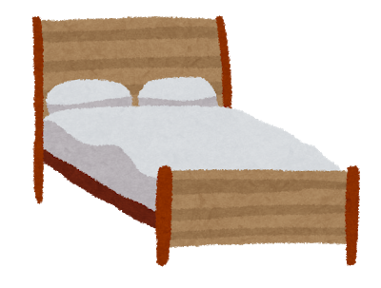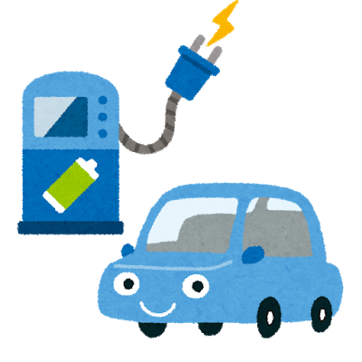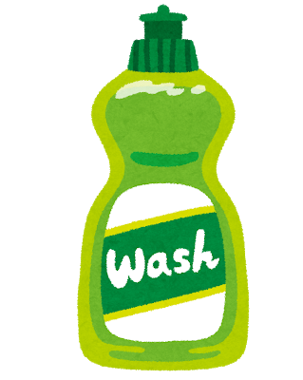

- Watch the video and write down what you think is happening. Discuss it with your classmates.
________________________________________________________________________________________________________________________________________________________________________________________________________________________
NNN. (2020, January 9). 「オリパラ選手村の段ボール製ベッド公開」. Retrieved March 3, 2020, from https://www.youtube.com/watch?v=CdfBOPZruPA. (JAPANESE VIDEO about the Olympics village)
WZDW News FOX. (2019, October 25). Athletes at 2020 Tokyo Olympics will be sleeping on cardboard beds. Retrieved February 26, 2020, from https://www.youtube.com/watch?v=rYPO6pKxzpw. (ENGLISH VIDEO about the Olympics village)

- Look at the key vocabulary.
Find the listed words in the puzzle. Words can appear vertically and horizontally.
- かんきょうenvironment
- リサイクル recycle
- ダンボール cardboard
- ひつよう necessary
- やさしい friendly, kind
- つかいます to use
- すてます to throw … away
ま | や | あ | く | つ | し
い | さ | ろ | て | か | せ
け | し | よ | ひ | い | す
み | い | め | つ | ま | て
お | せ | ゆ | よ | す | ま
か | ん | きょ | う | む | す
ダ | ン | ボ | ― | ル | わ
ま | リ | サ | イ | ク | ル

Notes: ダンボール、ボール comes from (card) board.

During Reading
- Answer the following questions.
  - What did The Tokyo Organising Committee of the Olympic and Paralympic Games introduce?
  - What are the beds made of?
  - What will the Tokyo Organising Committee of the Olympic and Paralympic Games do with the beds after the Olympics and Paralympics?
  - What does the writer of this article think about these beds?

- Summarize what you have read. Fill in the blanks below and complete the sentences with the following words.

2020年東京オリンピック・パラリンピックでは、＿＿＿＿＿をたいせつにしています。ですから、＿＿＿＿＿＿＿のベッドをつくりました。オリンピック・パラリンピックのあとに、ベッドを＿＿＿＿＿＿＿します。
かんきょう
ダンボール
リサイクル

After Reading
- Indicate whether the following sentences are true (〇) or false (×).
（ ）The beds and tables are made from cardboard.
（ ）A person who weighs 200kg can sleep on the cardboard beds.
（ ）The writer of this article said the recycled beds are a good idea.

- Reading extension and discussion
Read the following comments about the recyclable beds and mattresses, then research opinions of people around the world.

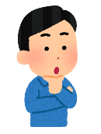
オリンピック選手はいろいろな国から日本にきます。わたしたちのゲストです。ゲストの選手たちがダンボールのベッドにねます。それは、しつれい(impolite) です。

ベッドは、新聞紙(newspaper)になります。リサイクルできます。いいですね！

Share your findings and your opinions with your classmates.
Example:
わたしは、ダンボールのベッドがいいです。今、オーストラリアでも、かみのストローがあります。かんきょうにいいです。

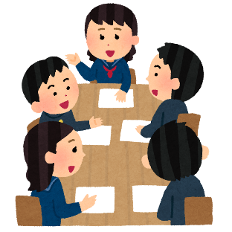
そうですね。
なるほど。

- Research
As well as the beds, there are other recyclable products that will be used for the Olympics. Research the other products and give a presentation to your class.

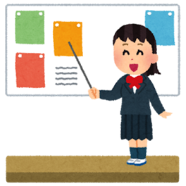
Example:
これは、日本の選手のユニフォームです。ふるい服で、つくりました。環境にやさしいです。

Other suggestions for research:
メダル (medal)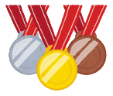、ひょうしょうだい(winners’ podium)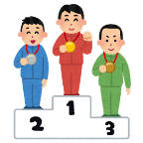
Answer key:
Before reading
1.
a. The Olympics: July 24th – August 9th / The Paralympics: August 25th – September 6th
b. The Olympics: 33 sports 399 events / The Paralympics: 22 sports 539 events
c. The Olympics: At maximum 12, 000 athletes/The Paralympics 4,400 athletes
d. Sport, Culture, Environment
2.
a. ☑ b. ☑ c. ☑
6.
 | や |  |  | つ
 | さ |  |  | か
 | し |  | ひ | い | す
 | い |  | つ | ま | て
 |  |  | よ | す | ま
か | ん | きょ | う |  | す
ダ | ン | ボ | ― | ル
 | リ | サ | イ | ク | ル

