Listen to Katsura Sunshine talking about his language learning experiences!

Watch the video interview to learn about Katsura Sunshine's language learning experiences.

いつから 日本語の べんきょうを はじめましたか。☆
１．
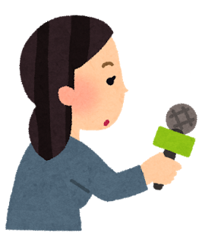

あ）15さいのとき はじめました。
い）2015年に はじめました。
う）15年前に はじめました。

どうやって 日本語を おぼえましたか。☆☆
２．

あ）うちで べんきょうしたり テレビを 見たりして おぼえました。
い）人に であったり 話したりして おぼえました。
う）うたを うたったり 本を 読んだりして おぼえました。

どうやって らくごを マスターしましたか。☆☆
３．

あ）たくさん きいて マスターしました。
い）たくさん はなして マスターしました。
う）マスターしていません。

日本語の かんたんなところ、むずかしい ところを おしえてください。☆☆☆
４．

In his answer to this question, Katsura Sunshine gave the words below as an example of むずかしいところ. What specific difficulty is he referring to?
食べる、 食べます、 めしあがります、 いただきます

