Elephant Song
ぞうさんZoo-san

Japanese
ぞうさん ぞうさん
Zoo-san zoo-san

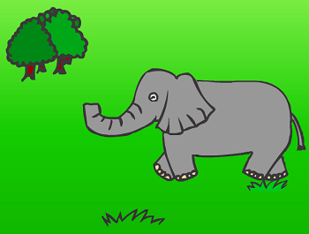
おはな が ながいのね
Ohana ga nagainone
そうよか あさん も ながいのよ
Sooyo kaasan mo nagainoyo
ぞうさん ぞうさん
Zoo-san zoo-san

だあれ が すきなの
Daare ga sukinano

あのね かあさん が すきなのよ
Anone kaasan ga sukinanoyo

English Translation
Little elephant, little elephant,
You have a long long nose.
Yes sir, my mother has a long nose, too.
Little elephant, little elephant,
Who do you like best in the world?
Well, I like my mother best in the world.

