Forms of Kanji
Kanji can be divided into four main groups according to how they are formed: 象形文字 (pictographs), 指示文字 (sign characters), 会意文字 (kanji with combinations of meanings), and 形成文字 (kanji with combinations of meaning and sound). 形声文字 are kanji made up of two or more components, one representing sound and another representing meaning, and they make up the majority of kanji in daily use. The components which give the meaning are called 部首, radicals. Although 形声文字 may look complicated, once they are divided into radicals and other components, they become simple. Radicals are classified into seven types, based on where they appear.

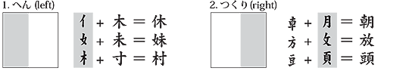
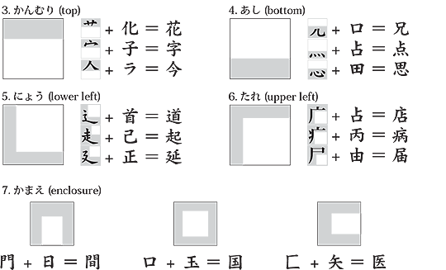
Task 1: Find the common feature in the following groups of kanji and fill in the 'radical' and 'English' sections. (This task is useful not only for kanji learning but also for developing literacy and understanding of language as a system.)
 | Radical | Hinted meaning  (original shape of radical) | English
肝(liver) 脳(brain) 腹(stomach) 肩(shoulder) |  | 肉（にく） | flesh, meat
打(to hit) 投(to throw) 折(to fold) 招(to invite) |  | 手（て）
海(sea) 洗(to wash) 波(wave) 酒(alcohol) |  | 水（みず）
草(grass) 花(flower) 茶(tea) 薬(medicine) |  | （くさ） (not used now)

Task 2: Classify the following kanji according to their radicals.
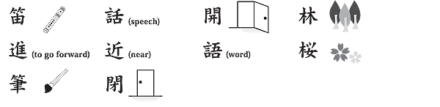
部首 (radical)
名前 (name) | きへん | ごんべん | たけかんむり | しんにょう | もんがまえ
意味 (meaning)
漢字 (kanji)

Task: Rank the kanji in order of number of strokes
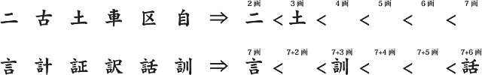
Once students are able to accurately count strokes, they can be given tasks using dictionaries. The following task can be done using the headlines above.
Task: Find the meanings of:
1.捕鯨推進_______________________________________________ | 4.豪州人___________________________________________________
2.刺殺______________________________________________________ | 5.連邦政府._______________________________________________
3.大陸横断道路_________________________________________ | 6.判決_______________________________________________________

