しらべよう！
お米とわたし
Answer the following questions.
1. ごはんをよくたべますか？ How often do you eat rice?
☐ よく たべます
☐ ときどき たべます
☐ あまり たべません
☐ ぜんぜん たべません
2. どんなごはんりょうりがすきですか？ What rice dishes do you like?
ぼくは日本のカレーライスがすきです。
わたしはタイのグリーンカレーがすきです。

3. いつもどんなお米をたべていますか？What kinds of rice do you usually eat?
- どんなかたち？(What shape is it?)
☐ みじかいshort ☐ ながいlong ☐ まるい round ☐ ほそいthin

- どんないろ？(What colour is it?)
☐ しろ ☐ くろ ☐ あか ☐ みどり ☐ ちゃいろ

- しょっかんは？(What texture is it?)
☐ モチモチsticky ☐ パラパラdry ☐ しっかりsolid ☐ やわらかいsoft

4. Is there only one type of rice? Look at the rice section of your local supermarket to find out the answer!
いろいろなおこめがあります！
オーストラリアの米づくり Rice farming in Australia
Read the brief information about the Australian rice industry on pages 104-107 of the book as a reference.

1. オーストラリアのお米クイズ
Read each sentence below and write 〇 for True × for False.

a | ____ | やく3千万人の人がオーストラリアの米をたべています。  Around 30 million people in the world eat Australian rice.
b | ____ | 日本でオーストラリアの米をかうことができます。  You can buy Australian rice in Japan.
c | ____ | ニューサウスウェールズ州やビクトリア州で米をつくっています。Australian rice is grown in New South Wales and Victoria.

2. お米ときせつ (seasons)
Choose the appropriate season for each process of growing rice (a) - (d).
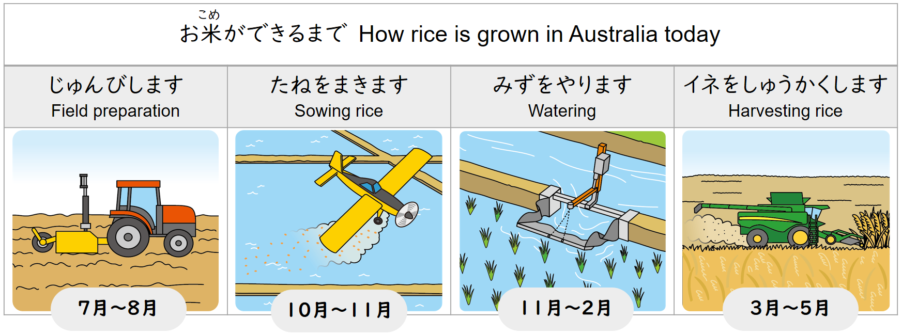

a. _____________ b. _____________ c. _____________ d. ____________
Choices: はる なつ あき ふゆ

3. お米とどうぐ (tools)
A rice farmer is interviewed about how rice farming has changed over time. By using the pictures below as a clue, choose the right words from (あ) – (う) to fill in the blanks (a) – (c).

むかしは、どうやってお米をつくりましたか^{*1}。

むかしは、a)_____________のちから^{*2} を かりました^{*3}。

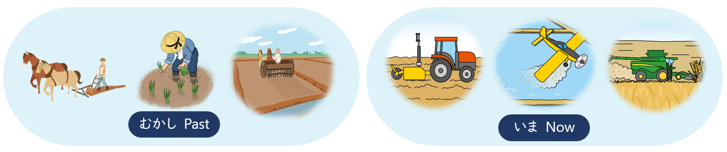
いまは、どうやってお米を つくりますか。

いまは、b)_____________やc)_____________をつかいます^{*4}。

Choices: (あ) どうぶつ animals (い) ヘリコプター (う) トラクター

^{*1}つくります… to make ^{*2}ちから… power
^{*3}かります… to borrow ^{*4}つかいます… to use
4. 米づくりでたいせつなこと
What are the important elements to successful rice farming?
Choose the right word from (あ) – (う) to complete a sentence below.
お米をつくるとき、
a) __________ とb) __________ とc) __________ がたいせつです。

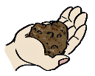

Choices: (あ) つち (い) みず (う) てんき

Answer keys:
1. a. × (40 million) b. 〇 c. 〇
2. a. ふゆ b. はる c. なつ d. あき
3. a. あ b. い/う c. う/い
4. a. う b. あ c. い

