Before Reading
A. Think and share
1. Do you have any favourite historical figures? Who? Why do you like them?

2. Have you ever read their life story/stories (biography/biographies) in English?
☐ はい
☐ いいえ

3. If you selected はい to Question 2, what information did you find out through reading their biography/biographies?
You may tick multiple answers below:
☐ Place of birth
☐ Date of birth
☐ Date of death
☐ Childhood
☐ Education
☐ Occupation
☐ Family
☐ Significant life events
☐ Achievements
☐ Other ______________________

4. Do you know a famous Japanese person who lives/lived in Australia? Who? What is/was that person famous for?

B. Read and guess
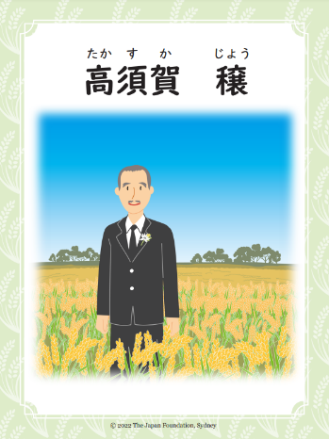
1. タイトルは何ですか。Look at the title of the book to find out who this book is about.

2. Look at the image on the cover page of the book. Can you guess what the story is about?

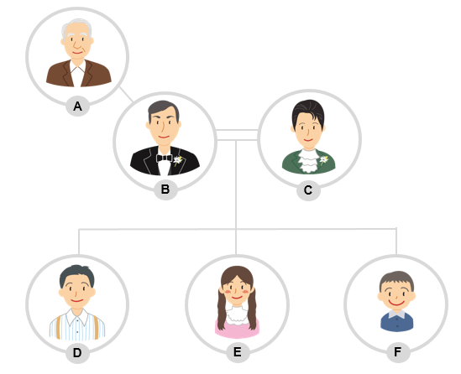
3. キャラクターの名前は何ですか。Look at page 5 to find out main characters’ names (A) – (F). Choose the right name from (あ) – (か) in the box below.

(A) ______________
(B) ______________
(C) ______________
(D) ______________
(E) ______________
(F) ______________
(あ) まりお (い) あいこ (う) ショー
(え) いちこ (お) ジョー (か) かへい

C. Research the setting and time period
Read the brief background of this story on pages 6-7 of the book.
1. Find out what Japan and Australia looked like in the 1900s.
- What was Australia like in the early 1900s?
e.g. What happened in 1901?
e.g. Was it easy for migrants to come to Australia in the early 1900s?
- What was happening in Japan at this time?
- Do you think it was common for Japanese people to travel and study around the world in the 1900s?
2. ジョーはどこでうまれましたか？ Circle the name of the city where Jō was born.
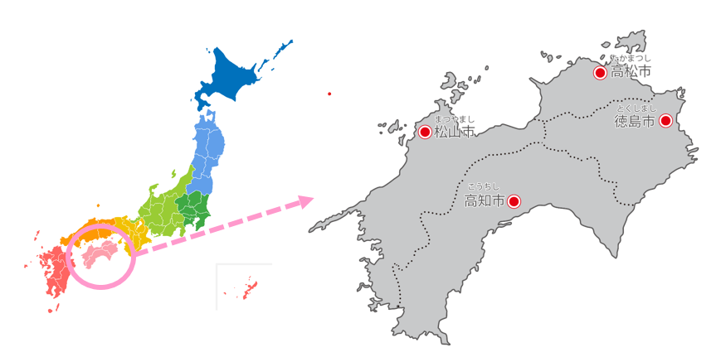

3. Watch the video and answer the following questions.
🎥 Watch the following video from the beginning to 1:06:
Sun Rice. (2018, November 6). Japanese captions – the Japanese origins of Australian short grain rice. Retrieved April 27, 2022 from https://www.youtube.com/watch?v=r5TRozhq608.
- ジョーはいつオーストラリアに来ましたか。When did Jō come to Australia?
- ジョーはオーストラリアで何をしましたか。What did Jō try to do in Australia?
4. After watching the video, what more do you want to know about Jō?

