After Reading
A. Summarise
1．What was the most significant accomplishment in Jō’s life? Choose the right word from the choices below to fill in the blanks (a) - (b).
ジョーは (a)＿＿＿＿＿＿＿＿で、はじめて (b) ＿＿＿＿＿＿＿＿を つくりました。ですから、(a)＿＿＿＿＿＿＿＿でとてもゆうめいです。

Choices: こめ オーストラリア

2. Describe the main character’s personality.
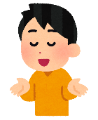
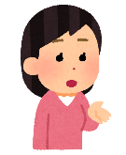
Tick words that describe Jō’s personality. Explain why you think so by giving examples from the text.
3. Complete the mini-biography about the main character.
☐ やさしい人 kind person ☐ げんきな人 energetic person
☐ あかるい人 cheerful person ☐ ゆうきのある人 courageous person
☐ まじめな人 serious person ☐ まけずぎらいな人 competitive person
☐ わがままな人 selfish person ☐ よくばりな人 greedy person
☐ いっしょうけんめいな人 hard working person
☐ おもいやりのある人 thoughtful person ☐ ＿＿＿ がすきな人 person who likes…
☐ Other: ___________________________

ジョーは どんな人でしたか。
ジョーは 〇○でした。
○○だったと思います。

うまれたところPlace of birth
せいかくPersonal traits
たっせいしたこと Achievements

Three Interesting Facts
★
★
★
年 ～ 年
なまえ
Interesting Facts

B. Make connections
1. Do you have any advice for the main character?
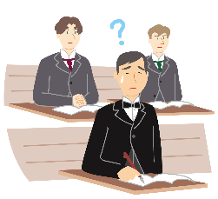
In the story, Jō was struggling to learn English (see page 19).
Do you have any advice on how to learn a foreign language?

2. Do you have any mottos? (See page 21)
Take a look at Jō’s mottos as well as Japanese students’ mottos:
わたしのモットーは、「プライドをもつ (Be proud of being a Japanese) 」、「マナーをまもる (Have good manners) 」、「あきらめない(Never give up)」です。

ジョー
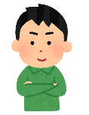
ぼくのモットーは、「ゆうき (courage) 」です。
じゅん（14さい）
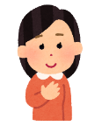
わたしのモットーは、「おもいやり (consideration) 」です。

ゆり（12さい）

あなたのモットーは何ですか？What is your motto?

Useful words
○○をたいせつにします (to cherish, value, take care of…) ともだち (friend) かぞく(family)
いっしょうけんめい (trying as hard as you can) チャレンジ (challenge) えがお (smile)

Source: Kids@nifty. (n.d.) 「キッズなんでも相談：みんなの悩み、みんなで一緒に考えよう！」<https://kids.nifty.com/cs/kuchikomi/kids_soudan/list/aid_220223119393/1.htm>
3. How would you encourage the main character?
In the story, Jō was struggling to grow rice (see page 69). When his father was leaving Australia, he sent encouragement to Jō by sayingあきらめるな！“Don’t give up!”
Imagine if you were a friend of Jō, what would you say to him?
e.g.
☐ あきらめないでください。
☐ がんばってください。
☐ だいじょうぶです。
☐ たいへんですね。
Other: ___________________

4. If the main character were still alive, is there anything you would like to ask him? Imagine what Jō’s answer to your questions would be.
Write your answers referring to the example below:

ジョー

Example:
どうしてアメリカの大学にいきましたか。
アメリカの大学で、
いちばんおもしろかったことはなんですか。

アメリカの大学で、あたらしいことをべんきょうしたかったです。べんきょうはおもしろかったです！
ジョー
5. Compare your life with the main character’s life. In the story, Jō came to an unfamiliar place, tried various things and faced many difficulties. Have you, or somebody around you ever had a similar experience to Jō?
Write your answer referring to the example below:

Example:
わたしもチャレンジすることが好きです。
きょねん、バレエをはじめました。とてもむずかしかったです。でも、まいにちれんしゅうしました*。
しょうらい、バレリーナになりたいです。

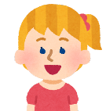
* れんしゅうします to practice
ぼくのそふはイタリア人です。
1950年にオーストラリアにきました。
こうじょうではたらきました。
いまは、レストランのオーナーです。
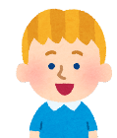

6. In the story, the author described the main character, Jō as a person who loved to challenge himself with new things. Do you like to try out a lot of different things? Or, do you like to pursue one thing thoroughly? Why is that?
Let’s share!
Is there something new that you would like to challenge? Or, is there something you are currently passionate about?

Write your answer referring to the example below:

Example:
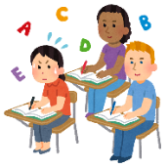
わたしはオーストラリアの高校にりゅうがくしたいです*。

あおい （17さい）

*りゅうがくします to study abroad
インターンシップにチャレンジしたいです！

さき （18さい）
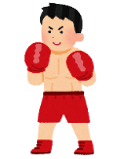
ぼくはボクシングが大好きです。
まいにちれんしゅうしています。
まさき （13さい）

Sources:
Koukouseishinbun. (January 3, 2022). 「2022年、高校生・中学生が掲げる「新年の目標・抱負」まとめ」＜https://www.koukouseishinbun.jp/articles/-/8391＞
Koukouseishinbun. (January 6, 2021). 「高校生の新年の抱負・目標・やりたいこと一覧「勉強マニアになる」「体力をつける」」＜https://www.koukouseishinbun.jp/articles/-/7170＞

C. Research and write
Write a mini-biography.
Option 1: Research about a person who inspires you or has impacted your life.
OR
Option 2: Research about any Japanese person who is/was famous in Australia or any Australian who is/was famous in Japan.

Find out the information below:
- たんじょうびはいつですか。When is their birthday?
- どこでうまれましたか。 Where were they born?
- どこでべんきょうしましたか。Where did they study?
- なにをべんきょうしましたか。 What did they study?
- しごとはなんですか。What is/was their occupation?
- どんなせいかくですか。 What is/was their personality like?
- どうしてゆうめいですか。 What are they famous for?

SAMPLE ANSWER (A-3)
40さいのとき、オーストラリアにきました。
アメリカの大学に行きました。
さむらいの子どもでした。
日本 えひめ県 まつやま市
Three Interesting Facts
★
★
★
年～ 年
なまえ たかすか じょう
Interesting Facts

うまれたところPlace of birth

せいかくPersonal traits
いっしょうけんめいな人

たっせいしたこと Achievements
オーストラリアではじめてこめをつくりました。

1940
1865

