Activity 4.3 For Junior secondary
The following people are interviewed at a supermarket in Japan.
1. Read their responses below to find out which eggs they are buying and why.
わたしは、なまたまごと、ごはんを  たべます。  なまたまごは、おいしいです！  フリーレンジはきたないですよ。  ケージたまごはきれいであんぜんです。  だから、ケージたまごをかいます。  *なまたまごraw egg *あんぜん safe  にしかわ  おおた | 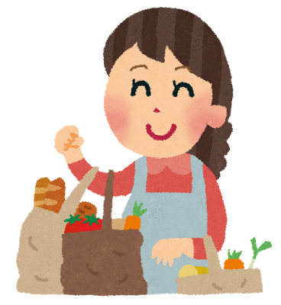  なかしま  フリーレンジ、いいですね。  でも、たかいです。  ケージのたまごはやすいです。  そして、おいしいですよ。  まいにちたべます。  だから、ケージたまごをかいます。
ケージとフリーレンジ…？  どうちがいますか？  ちょっとわかりません。  ビタミンのはいっているたまごをかいます。  ビタミンはからだにいいですよ。  *eggs contain vitamins  おおたに | わたしはフリーレンジをかいます。  でも、フリーレンジたまごは、  スーパーにあまりありません。  だからインターネットでかいます。  ケージのニワトリはかわいそうです。  *internet  まつもと
2. Discuss with your partner what you think of their opinions.

Activity 4.3 For Senior secondary
タスク
「フリーレンジたまごについて」みんなの意見を読みましょう。Read the opinions below.
あまりよくわからないんですが…  フリーレンジのたまごはふん*がついていたり、新しいかどうかわからないと聞きました。  たまごかけごはんは、日本の大切な文化です！  わたしは、たまごかけごはんが好きですから、きれいで、安全な*たまごが買いたいです。  ケージたまごを買います。  *ふんpoo *安全です safe  にしかわ  おおた | フリーレンジ、いいことだと思います。  でも、ケージのたまごは10こで200円、フリーレンジのたまごは10こ700円です。  どちらも、栄養*は同じだと聞きました。  同じだったら、わたしは安いたまごを買います。  うちは、お金持ち*じゃありませんから。  *栄養 nutrition *お金持ち rich  なかしま
おおたに  ビタミンEは肌*にいいと聞きました。体にもいいです。だから、少し高くても、ビタミンEがたくさん入っているたまごを買っています。  ケージたまごとフリーレンジたまご…？何がちがいますか？今まで考えたことがありません。わたしの友だちもみんな、考えたことがないと思いますよ。  *肌 skin | わたしは、フリーレンジのたまごを買っています。ケージのニワトリはかわいそうですから。  フリーレンジたまごは、スーパーにあまりないので、いつもインターネットで買っています。ちょっと不便ですね。  むかしは、フリーレンジのたまごは高すぎると思っていました。でも、チョコレートやおかしを少し我慢したら*、買うことができます。  それに、毎日たまごを食べなくてもいいと思います。野菜やサプリメントもありますから。  *我慢します to persevere/resist  まつもと

