Extra task
While students watching the movie
- 映画の中の日本の文化を見つけましょう。
What did you notice in the movie that showed Japanese language and culture? Write down anything you saw or heard during the movie in the box below and share them with your classmates.
E.g. 卒業のセレモニーがありました。

____________________________________________________________________がありました。
____________________________________________________________________と言いました
______________________________________________________________________をみました

After the movie, discuss in the class.
それは、あなたの文化にありますか。あなたの文化とくらべてみよう。
Did you notice any similarities or differences to your culture? Is there anything in your culture that you can compare with your findings? Discuss in your class.

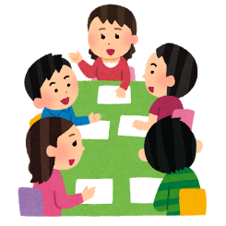
E.g.私たちも卒業のセレモニーをします。でも、日本のセレモニーとちがいます。
わたしの学校ではドレスをきてパーティーをします。

_______________________________________________________________________________________
_______________________________________________________________________________________
_______________________________________________________________________________________

