Extra task
While students watching the movie

①映画の中の日本の文化を見つけましょう。Let’s find examples of Japanese culture in the movie!
Is there anything in the movie that is similar or different from your culture? Write down anything you found out during the movie in the box below and share them with your classmates.
E.g. 卒業のセレモニーがありました。

がありました。
と言いました。
を見ました。

②あなたの文化とくらべてみよう。Let’s compare this with your own culture!
How are they similar or different from your culture? Discuss it in the class after the movie.

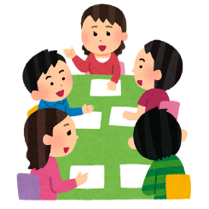
E.g. わたしたちも卒業のセレモニーをします。でも、日本のセレモニーとちがいます。
わたしの学校ではドレスをきてパーティーをします。

