Activity 3: Express appreciation
Step 1: Look at the interaction via email between the two students.
Zara went to Japan as an exchange student for two weeks. She was hosted by Masaru’s family.
Message to Masaru
TO
suzuki_masaru@tokyo.edu.jp

ホームステイのおれい
Subject
まさるくん
こんにちは。ザラです。
きのうキャンベラにつきました。
２しゅうかん、とてもたのしかったです。
いちばんのおもいでは、キャンプです。
みんなでカレーをつくりましたね。おいしかったです。
ほんとうにありがとうございました。
こんど、オーストラリア にあそびにきてください。
またね。
ザラ
ザラです。
にほんに、また
いきたいなぁ…。

Send

Message from Masaru
zara_smith@canberra.edu.jp
TO
まさるです。ザラさんがオーストラリアにかえりました。
さびしいな…。
ホームステイのおれい
RE

ザラさん
メールありがとう。
ぼくもとてもたのしかったです。
カレー、おいしかったですね。
キャンプのしゃしんをおくります。
らいねん、オーストラリア にいきたいです。
またメールします。
まさる

Send

After reading the emails, answer the questions below.
- True or False
  - ____ Zara’s favourite memory in Japan was camping.
  - ____ Masaru wants to go to Australia this year.

- Identify the following in each email.
  - Sender’s name
  - Receiver’s name
  - Greeting
  - Closing
  - Sender’s signature
  - Email subject

Step 2: Read the given situation and brainstorm.
Situation: You went to Japan as an exchange student for 2 weeks. Write a thank you email to your host family, using the photos as inspiration.
The name of your host sister is やまだ はるみ (Yamada Harumi).

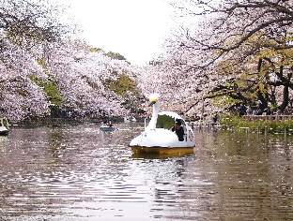
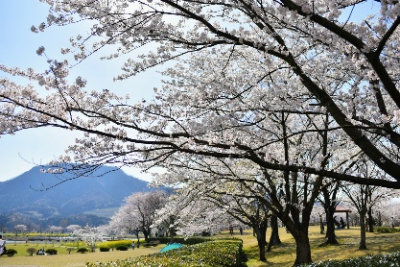
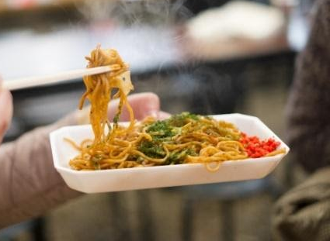
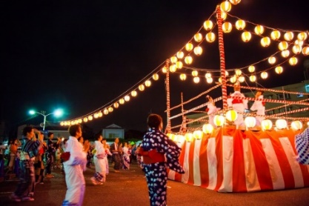
さくら cherry blossoms
おはなみ
Cherry-blossom viewing
おべんとう lunch box
ボートboat
やきそば fried noodles
はなび fireworks
ぼんおどり Bon dance
なつまつり
summer festival

Step 3: Draft your own email.
Subject
yamada_harumi@sapporo.edu.jp

TO

Send

Step 4: Review your final draft.
  - Did you write the subject of the email?
  - Did you write your name?
  - How did you address the person receiving this email? Why?
  - What expression did you choose for the greeting and closing? Why?

